How to mark a unit as having had a Service Bulletin performed on it.

- Go to the Service Module and click on Bulletins in the left hand side menu. Find the relevant service bulletin either by doing a search using function number 3 or browsing using function number 1. Remember that service bulletin numbers do not have any prefixes such as ‘sb’. Always use the numeric number only.
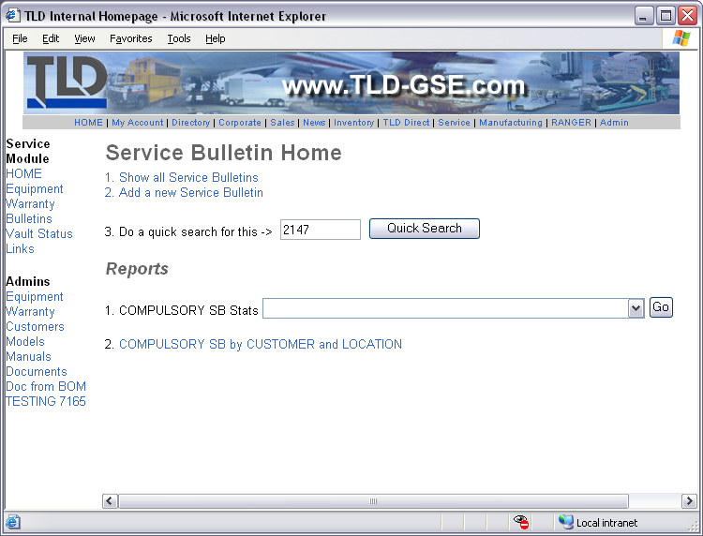
- Once you have found the correct service bulletin, click the magnifying glass to view the details.
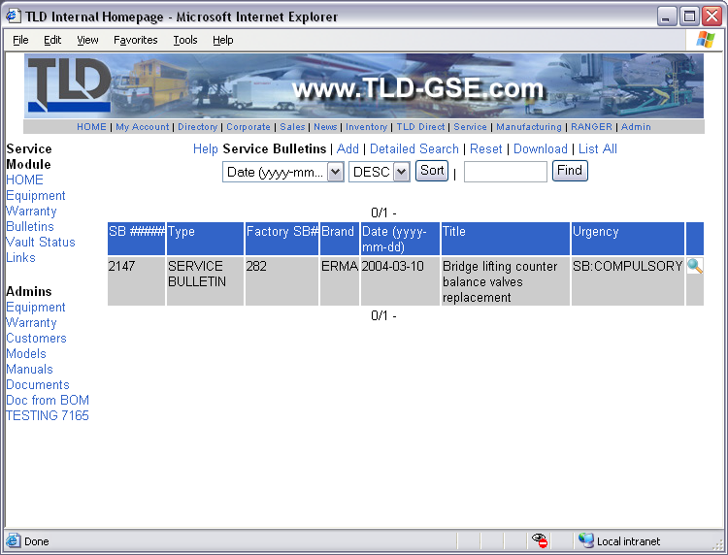
- At the top of the service bulletin, click the ‘Show Stats’ link.
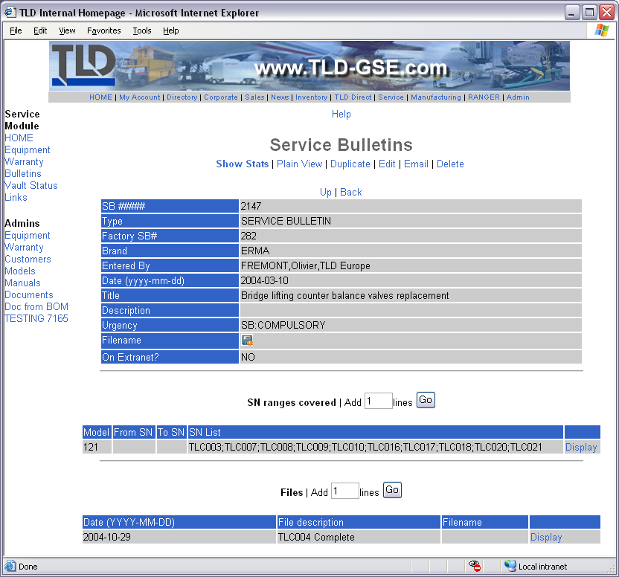
- The next page will be a report showing all units affected by the service bulletin. Any relevant service records will be shown below the serial number of the machine. Next to each serial number are two links: “Mark this unit as COMPLETE for this SB” and “Go to Equipment Record”. Clicking on the first link will automatically create a service record for the machine with all the required fields completed.
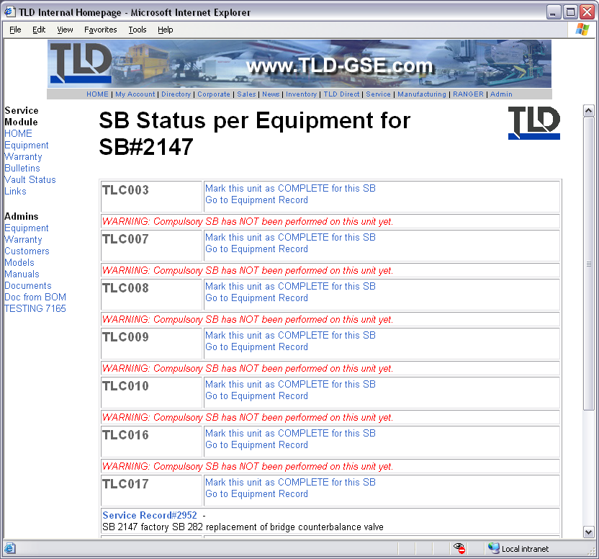
- The next page confirms the creation of the service record. From here you can edit the service record to add more information or go back to the list of affected units. It is very important that the Status, Work Type and Reason fields in the Service Record are not modified otherwise the machine will not be marked as being done.
